Part I
Pseudocode

BEGIN

DISPLAY "Enter the charge for the food"
INPUT food_charge

IF food_charge is not a number THEN
DISPLAY "Invalid input"
STOP
ENDIF

IF food_charge < 0 THEN
DISPLAY "Food charge cannot be negative"
STOP
ENDIF

SET tip_rate = 0.18
SET tax_rate = 0.07

CALCULATE tip = food_charge * tip_rate
CALCULATE tax = food_charge * tax_rate
CALCULATE total = food_charge + tip + tax

DISPLAY food_charge
DISPLAY tip
DISPLAY tax
DISPLAY total

END

Python

def calculate_meal_total():
try:
# Get user input
food_charge = float(input("Enter the charge for the food: $"))

# Validate input
if food_charge < 0:
print("Error: Food charge cannot be negative.")
return

# Constants
TIP_RATE = 0.18
TAX_RATE = 0.07

# Calculations
tip = food_charge * TIP_RATE
tax = food_charge * TAX_RATE
total = food_charge + tip + tax

# Output results
print("\n--- Meal Cost Breakdown ---")
print(f"Food Charge: ${food_charge:.2f}")
print(f"Tip (18%): ${tip:.2f}")
print(f"Sales Tax (7%): ${tax:.2f}")
print(f"Total Price: ${total:.2f}")

except ValueError:
print("Error: Please enter a valid numeric value.")

# Run the program
calculate_meal_total()

Output

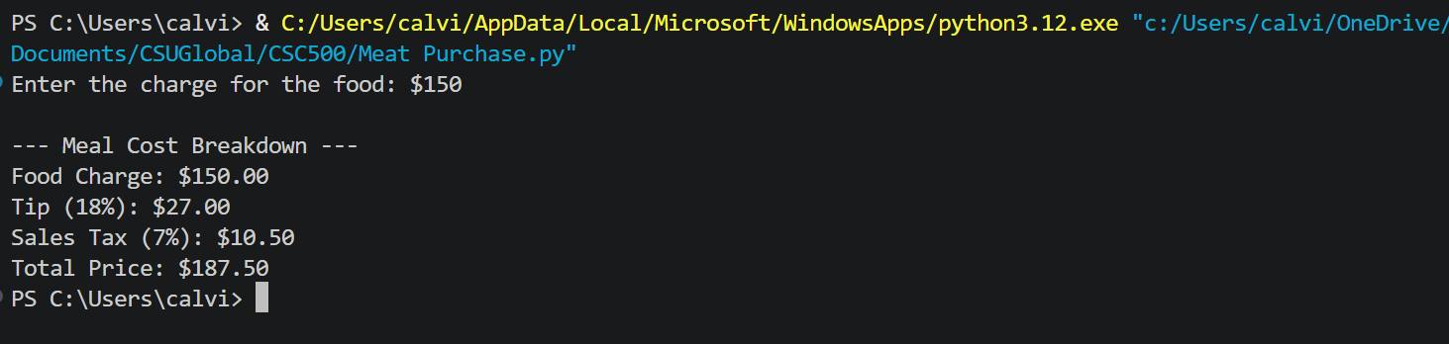

GitHub

https://github.com/calvinscroggins-dev/csu-python-scripts

Part II

Pseudocode

BEGIN

INPUT current_hour
INPUT current_minute
INPUT wait_hours
INPUT wait_minutes

IF current_hour not between 0–23 THEN
DISPLAY error
STOP
ENDIF

IF current_minute not between 0–59 THEN
DISPLAY error
STOP
ENDIF

IF wait_hours < 0 OR wait_minutes < 0 THEN
DISPLAY error
STOP
ENDIF

SET current_total_minutes = (current_hour * 60) + current_minute
SET wait_total_minutes = (wait_hours * 60) + wait_minutes

SET final_total_minutes = (current_total_minutes + wait_total_minutes) MOD 1440

SET final_hour = final_total_minutes DIV 60
SET final_minute = final_total_minutes MOD 60

DISPLAY final_hour and final_minute

END

Python

# This program calculates alarm time down to minutes using a 24-hour clock

def calculate_alarm_time_with_minutes():

try:
# Get current hour and minute
current_hour = int(input("Enter current hour (0-23): "))
current_minute = int(input("Enter current minute (0-59): "))

# Get wait time in hours and minutes
wait_hours = int(input("Enter hours to wait: "))
wait_minutes = int(input("Enter minutes to wait: "))

# Validate inputs
if current_hour < 0 or current_hour > 23:
print("Error: Hour must be between 0 and 23.")
return

if current_minute < 0 or current_minute > 59:
print("Error: Minute must be between 0 and 59.")
return

if wait_hours < 0 or wait_minutes < 0:
print("Error: Wait time cannot be negative.")
return

# Convert current time to total minutes
current_total_minutes = (current_hour * 60) + current_minute

# Convert wait time to total minutes
wait_total_minutes = (wait_hours * 60) + wait_minutes

# Add and wrap around 24 hours (1440 minutes)
final_total_minutes = (current_total_minutes + wait_total_minutes) % 1440

# Convert back to hours and minutes
final_hour = final_total_minutes // 60
final_minute = final_total_minutes % 60

# Output result
print(f"\nAlarm will go off at: {final_hour:02d}:{final_minute:02d}")

except ValueError:
print("Error: Please enter valid whole numbers.")

# Run program
calculate_alarm_time_with_minutes()

Output

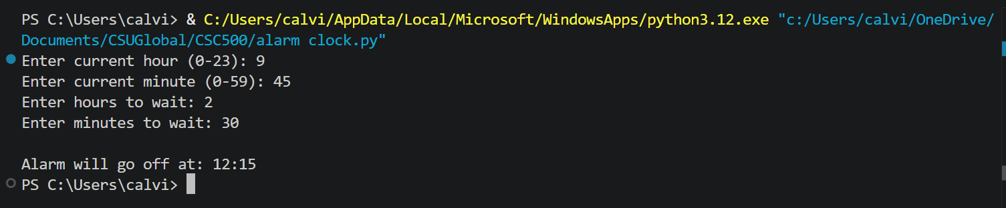

GitHub

https://github.com/calvinscroggins-dev/csu-python-scripts

